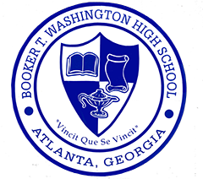
Greetings BTW Healthcare Science Advisory Committee:
Thank you for attending our Booker T. Washington High School Healthcare Science Advisory Committee Meeting! I am so encouraged by your commitment to our students and willingness to be a part of their education.
Together, we enhanced the vision for our program by setting both long- and short-term goals. Attached you will find the full list we created.
The below are three goals that were reoccurring in each group’s presentation. I would like us to use the below information to guide our work this year with our Healthcare Science Students. We will discuss more of what this might look like at our January 8th meeting. For now, if you have an ideas or opportunities, that align with these goals and could be implemented this semester please let me know.
1. Increase employability skills (public speaking, resume writing, mock interviews, personal finance)
2. Implement engaging, hands on activities with real healthcare professionals (dissections, case studies, technology)
3. Coordinate career exposure opportunities for students to gain access to both the healthcare profession and professional (job shadowing, internships, mentors)
I look forward to our continued work in accomplishing these goals.

Sincerely,

Mandie Lozano

